1. Click on the link below

<https://partner.cloudskillsboost.google/course_templates/295?catalog_rank=%7B%22rank%22%3A1%2C%22num_filters%22%3A0%2C%22has_search%22%3Atrue%7D&search_id=17709383>

1. The below screen pops up

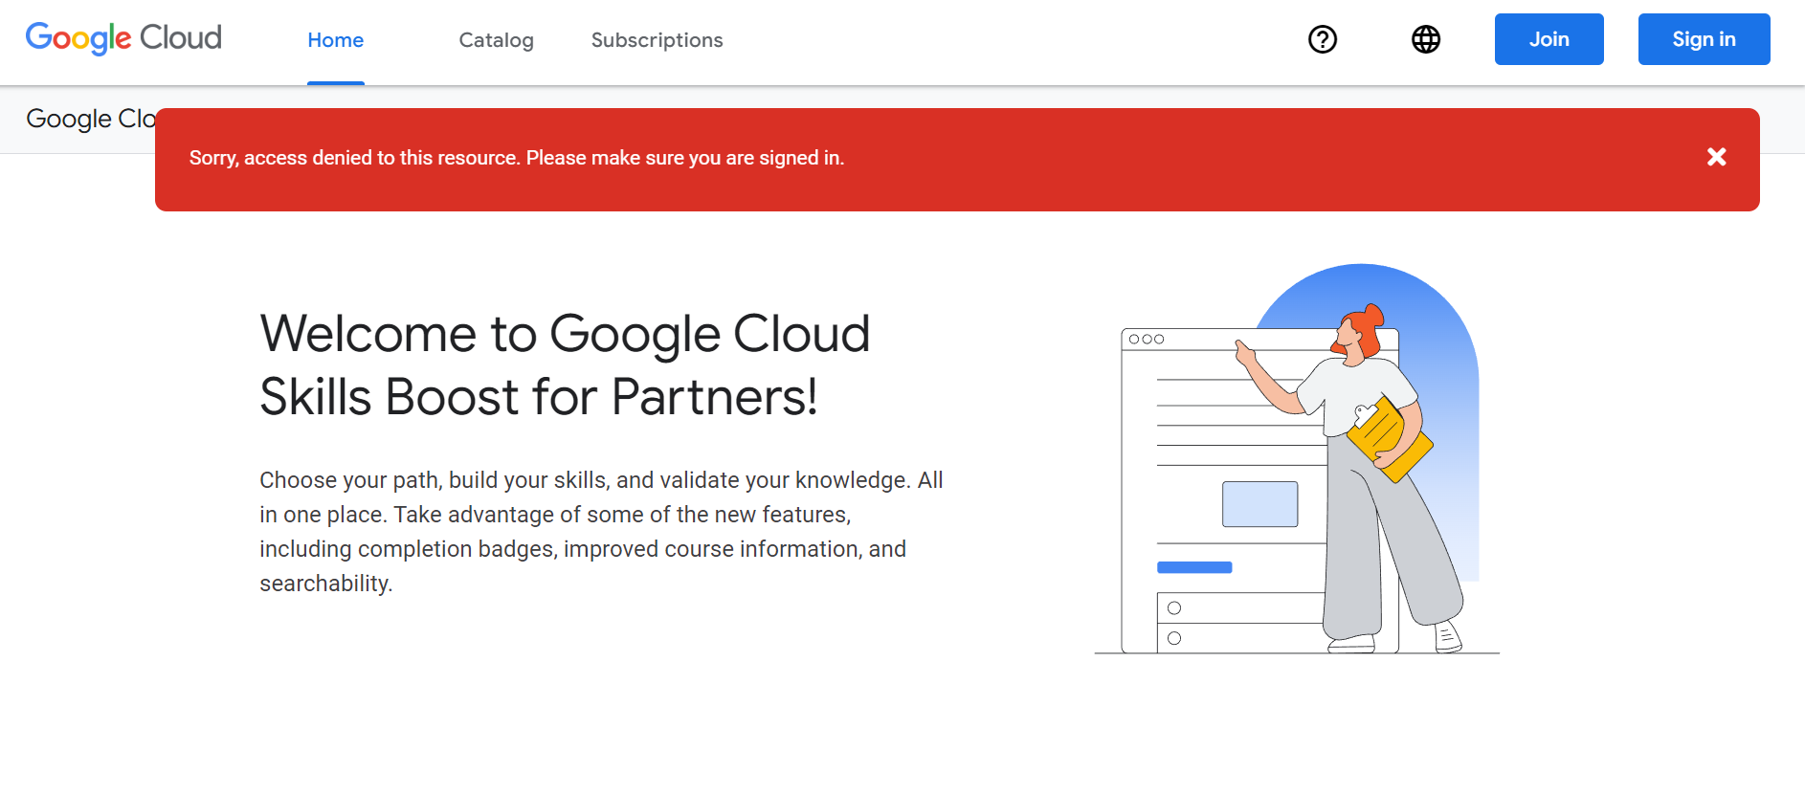

1. Now you need to create an account using your Deloitte email ID click on>> Join

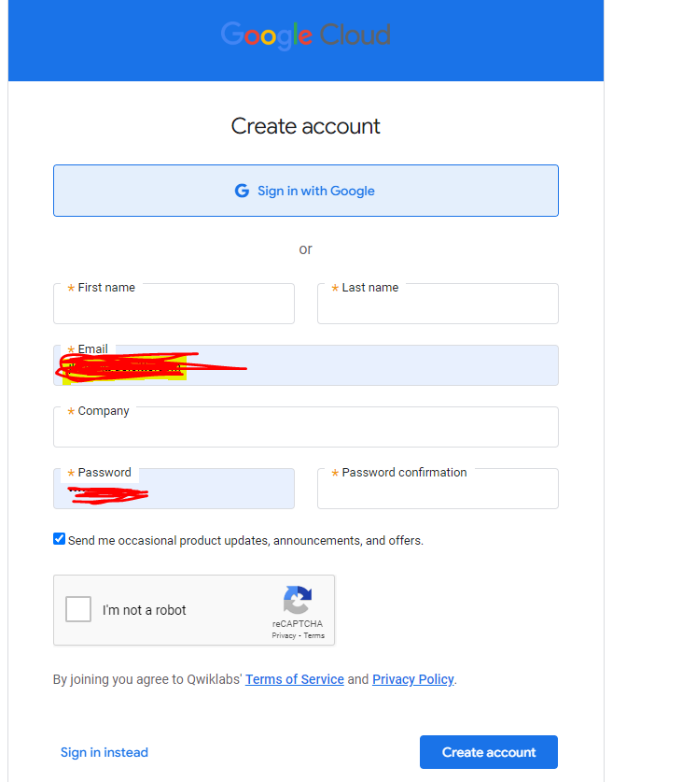

**Please use the Deloitte email id only.**

1. Once the above registration is complete, login again using the below link. Click on>>>Sign in option and enter your credentials as entered above.

<https://partner.cloudskillsboost.google/course_templates/295?catalog_rank=%7B%22rank%22%3A1%2C%22num_filters%22%3A0%2C%22has_search%22%3Atrue%7D&search_id=17709383>

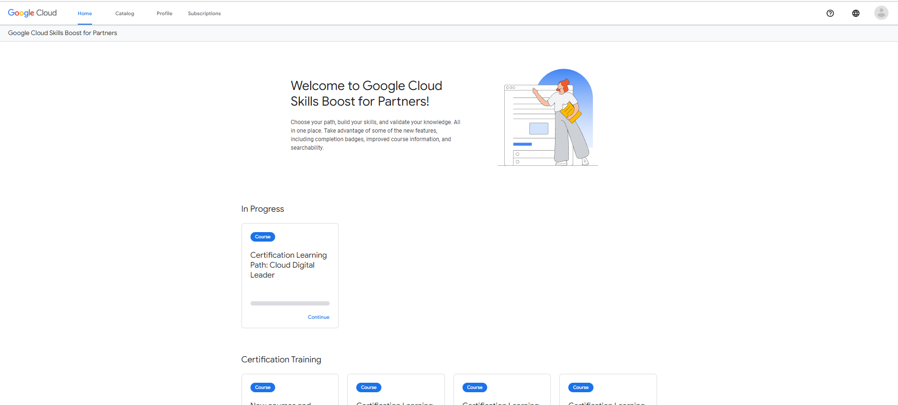

The above screen with the “certification Learning Path: Cloud Digital Leader” in progress will be shown. Click on the >>>Continue for the above course (Cloud Digital Leader).

1. Now you need to enroll for the course

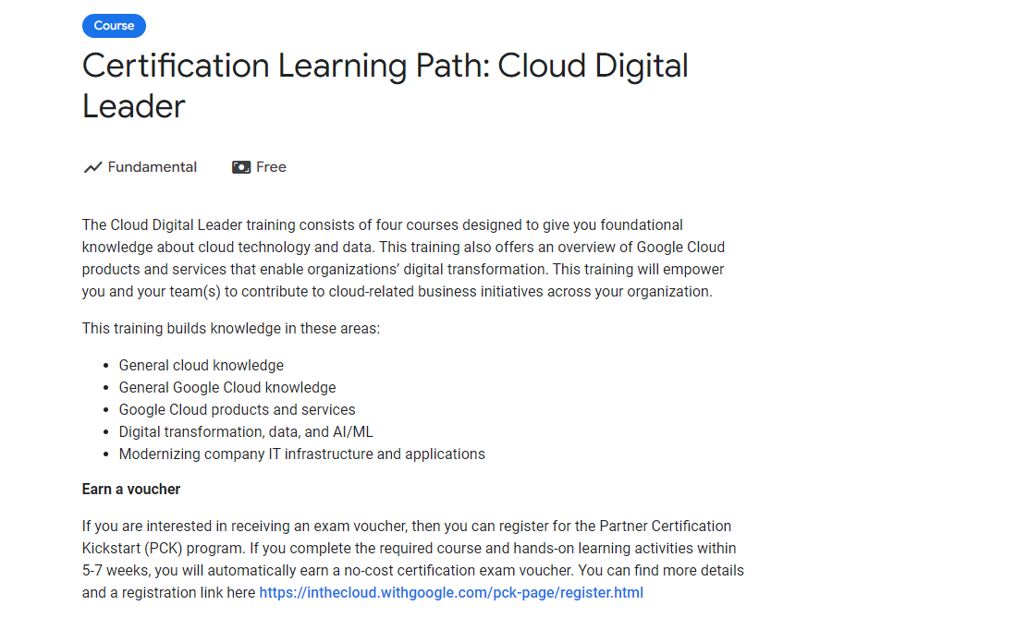  
***\*Please note the link needs to activated, the image is for illustration purpose***

1. Once enroll is completed the 4 modules with links will be visible.

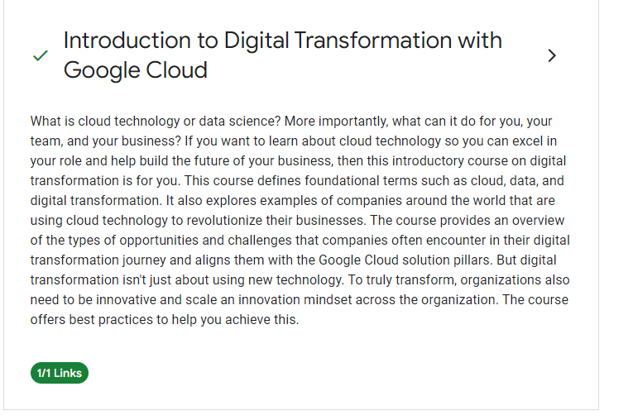

***\*Please note the link needs to activated, the image is for illustration purpose***

Activate each module to view the videos under each module.

1. Once all the 4 modules are completed proceed to exam registration. <https://webassessor.com/wa.do?page=login&branding=GOOGLECLOUD>

Please Refer the **ExamRegisterationProcess** Document to complete the registration for the exam.

1. Drop an email to Bakshi, Aalo - Ext [abakshi.ext@deloitte.com](mailto:abakshi.ext@deloitte.com) and K John, John [jkjohn@deloitte.com](mailto:jkjohn@deloitte.com) informing them of your exam date.
2. Post your exam, inform Aalo and John of the exam result. If you clear the exam, share the certification id with them.